TBT CHAI LIGHTS
  - The Monthly News of tEMPLE Beth Tikvah
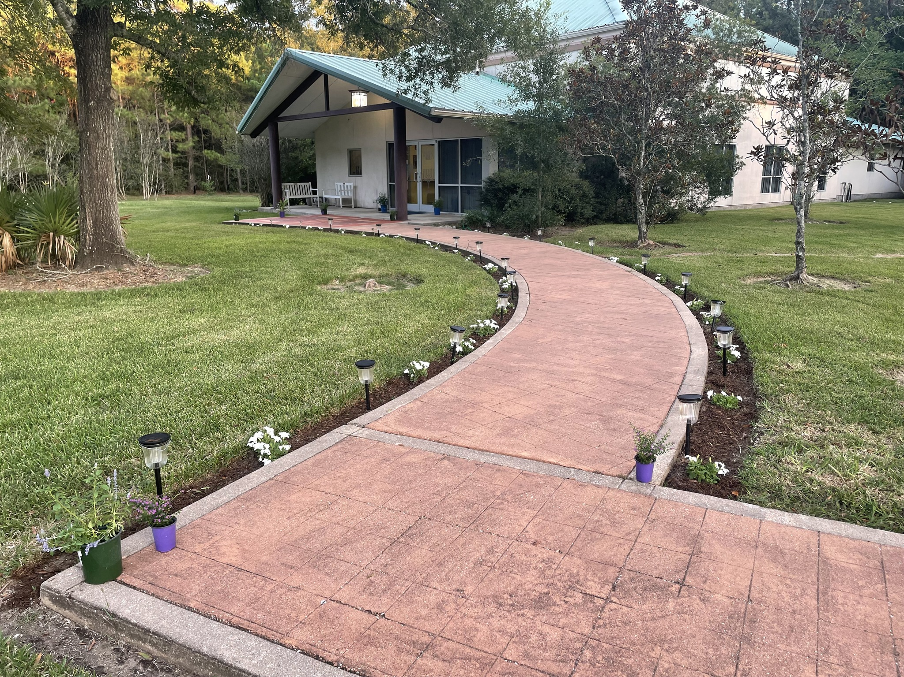Here you find the path towards hope.
In our fellowship, you find friends for life.
Within our temple walls is the warmth of joyful and welcoming worship.

Discover Temple Beth Tikvah:
Discover The Temple Between Trees.

November Services, Erev Shabbat

11/3/23 Myrna Reingold
11/10/23 Rabbi Marcy Greene
11/17/23 Myrna Reingold
11/24/23 Rabbi Marcy Greene

December Services, Erev Shabbat
12/1/23 Myrna Reingold
12/8/23 Rabbi Marcy Greene
12/15/23 Myrna Reingold
12/22/23 Rabbi Marcy Greene
12/29/23 Myrna Reingold
Temple Between Trees???  An odd suggestion it is, I suppose, to refer to our worship home as the Temple Between Trees. To understand the significance of this phrase, beyond the obvious reality of our location nestled within its own idyllic forest-like setting, I must share how I use the symbolism of trees in my work as a clinical therapist, a counselor. Often my clients come to me distressed by their trials, looking for some hope and possibly a nudge of direction. When these clients are facing an onslaught of trials and feeling attacked, I sometimes encourage them to think of the huge trees that line the streets of Galveston. With strong roots in good soil and a bark that is strong enough to withstand the rain and wind of category five hurricanes, these trees remain after over 100 years and countless storms. These tall, majestic trees provide shade and shelter to humans and animals in the area. Now, as our people are experiencing attacks and trials, both home and abroad, what is our answer to this tragedy. What is our role amid so much hatred, sorrow, and uncertainty? What can those who are the chosen messengers of G-d do?  So the question is for you, the readers, to reply with comments. We look forward to hearing your ideas. |  | November Board Meeting Canceled  The board meeting previously scheduled for Wednesday, November 8th was canceled. Joe Wallack was in Dallas at the US Open Pickleball Tournament. This happens to be the BIGGEST PICKLEBALL TOURNAMENT IN HISTORY, according to USA Pickleball. Good luck, Joe!!

Taste of Tel Aviv Burglarized: Go Fund Me Account Created
The restaurant, Taste of Tel Aviv, a Kosher restaurant located on Hillcroft, Houston, was attacked Tuesday morning, November 7, 2023, sometime after 3 a.m. as an unidentified individual who was spotted on video cam, cut through concrete and aluminum and other construction to access the restaurant from the roof. Prayer books and a cash register were stolen. Air conditioning, theft, and structural damage adds up to at least $50,000. A gofundme account has been created for donations to this Jewish owned business: https://gofund.me/3c20fb82

Take Time to Decompress and Reflect.

Then share with us!

rEFLECTIONS AND sUBJECTIONS

EDITORIALS, OPINIONS, AND CREATIVE SUBMISSIONS WELCOMED
What can be said of the events of the past month? Shock, horror, and heartbreak are the first words that I can conceive. But after all the musings and in the midst of the heartbreak, I ask, “What is my role in all of this tragedy?” Certainly, others will understandably ask what is God’s role, or what is the political role of certain entities. I leave those answers for someone much better equipped than myself. But for me, I wonder what does God ask of me? What do I ask of myself? As I ponder the answers to these questions, one memory stands strong, that memory is the reply that the volunteers of the Houston Holocaust Museum said to me during my visit there, years ago. I was touring the exhibits with my colleagues in the Graduate College of Social Work. Part of our orientation as new students in their program was to participate in a guided tour of the Holocaust Museum. At the beginning of the tour, the guides warned us of the graphic nature of the exhibits and informed us of the expectation that we should not hold hatred towards the perpetrators of the crimes. The graphic images were so disturbing, I was unable to complete the entire tour, so I went to speak with the volunteers at the front desk. “How do you keep from hating the German Nazis after seeing what they have done?”, I asked. One of the women spoke for both of them, “Because we don’t see the Nazi’s as our enemy. Hatred is our enemy. Hatred is what has done this evil. The Nazi’s were just a tool of hatred. Hatred is the true enemy.” The woman who stood next to the speaker silently nodded her agreement. Both bewildered and amazed, I silently walked away to ponder, wondering about the strength and courage one must have to hold such a view despite being confronted with the acts of hatred so graphically displayed before them. Today, I still wonder. Can I be that strong?

Sisterhood Happenings:

The Sisterhood met on Sunday, November 5th, for lunch and fun. TBT Chai Lights would love to receive comments or reflections on the past meeting to post in the next edition. Please contact Melissa Stewart, 281-678-7265 if you would care to share your own highlights or stories from the get-together.
The next Sisterhood meeting will be held on:
More details to follow.

Days to Remember

November Birthdays: Anniversaries:
- Neal Wallach 7 Adam and Jennifer Baker

- Amanda Vermillion 14 Robert and Leslie Wells

- Jovan Morales
10 Corinne Blancas
16 Stuart Eisen
17 Maury Klann
19 Yuri Kahn
20 Arlene Leboe
22 Bob Rivesman
25 Melissa Stewart
26 Elliot Leboe
27 Hannah Philibert

Note from the editor (aka Melissa Stewart): Please forgive formatting foibles. I am still learning and have tried numerous ways to fix them. Hopefully the next one will be better!

